Namita Utekar
DATA-430 Project 2: Data Processing and Analytics with Apache Spark
Date: Nov 9,2026

Build an orchestrated pipeline that cleans source data, produces Spark analytics, and loads validated results into

1. Executive Summary
This project extends the earlier data pipeline work by adding Apache Spark-based data processing and analytical transformations, orchestrated through Apache Airflow and persisted in PostgreSQL. The implementation uses containerized services to run the processing and database components in a repeatable local environment. The completed workflow validates source files, executes cleansing, generates analytical outputs, loads cleaned and analytical datasets into PostgreSQL, validates database results, and marks the workflow complete. The final Airflow run on November 5, 2026 completed successfully across all six configured tasks. The database contains three core entity tables (customers, products, and orders), the ETL audit table, and twelve analytics tables. Verified counts include 99,900 customers, 99,861 products, 98,457 orders, and all twelve expected analytics outputs.
1.1 Project outcomes
Containerized execution environment configured for Airflow, Spark, and PostgreSQL. Source datasets generated with 100,000 records per entity. Spark cleansing outputs persisted as Parquet for customers, products, and orders. Twelve analytical datasets generated and loaded into PostgreSQL. All six tasks in the final Airflow DAG run completed successfully. Database validation confirmed expected counts across fifteen core and analytics tables. ETL audit history retained successful loads and an earlier failed attempt.
1.2 Scope and evidence
This report documents the implementation and results verified during project work. Requirements not demonstrated by the available code or outputs are identified as limitations or future improvements rather than claimed as completed.
DATA 430 Project 2 | Apache Spark Data Processing & Analytics
2. Solution Architecture and Environment
The solution is organized into four layers: source data, Spark processing, orchestration, and relational storage. Airflow coordinates the workflow, Spark performs data preparation and analytics, and PostgreSQL stores resulting datasets and ETL audit records. Component Role Docker Compose Runs project services in isolated containers. Apache Airflow Orchestrates the six-task Project 2 DAG. Apache Spark Processes source data, writes cleaned Parquet data, and creates analytics outputs. PostgreSQL Stores core entities, audit records, and twelve analytics tables. Python scripts Implement cleansing, analytics, and database loading.
2.1 Local service endpoints
Service Container / endpoint Airflow data430_project2_airflow — http://localhost:8081 PostgreSQL data430_project2_postgres — host port 5433 Spark Master data430_project2_spark_master — http://localhost:8082 Spark Worker data430_project2_spark_worker — host port 8083 The PostgreSQL database is named data430. Credentials are stored in the local .env file and are intentionally not reproduced in this report.
2.2 Project organization
The project directory is DATA430_Project2. It includes Docker Compose configuration, Python requirements, data and scripts directories, SQL schemas, and an Airflow DAG. Principal components include spark_utils.py, spark_cleanse.py, spark_analytics.py, load_to_postgres.py, and dags/data430_project2_pipeline.py.
3. Source Data and Data Preparation
The project uses three related business entities: customers, products, and orders. The improved data-generation run produced 100,000 records for each CSV dataset. The generated data was designed to exercise data-quality handling.
DATA 430 Project 2 | Apache Spark Data Processing & Analytics
Entity Generated records Final database rows Customers 100,000 99,900 Products 100,000 99,861 Orders 100,000 98,457 The difference between generated and final row counts reflects processing and loading outcomes. The exact number attributable to each individual cleansing rule was not independently captured in the evidence summarized here; the differences should not be interpreted as per-rule rejection counts.
3.1 Cleansing workflow
The cleansing stage is implemented in spark_cleanse.py and supported by spark_utils.py. It processes customer, product, and order data and writes cleaned results in Parquet format for subsequent analytics and loading. Validate that required source files are available. Apply the project cleansing transformations to customer, product, and order records. Write cleaned entity datasets to Parquet output folders. Make the cleaned outputs available to analytics and database-loading stages.
3.2 Data-quality considerations
The project scenario includes duplicate identifiers, missing values, inconsistent casing and whitespace, invalid numeric values, inconsistent date formats, and orders that may not reference a valid customer. The loader was updated to normalize customer-type values before loading to PostgreSQL. This resolved the earlier case-sensitive check-constraint failure caused by the value 'Vip'. The final Airflow validation checks for orphan order-to-customer references. The successful final run indicates that this configured validation passed.
4. Spark Analytics
The Spark analytics stage is implemented in spark_analytics.py. It produces twelve analytical datasets, which are written to the analytics output location and loaded into corresponding PostgreSQL tables. Analytics output Rows Purpose customer_metrics 62,580 Customer-level lifetime value, order frequency, average order value, and customer type. top_10_customers 10 Top ten customers by the implemented customer revenue metric.
DATA 430 Project 2 | Apache Spark Data Processing & Analytics
Analytics output Rows Purpose customer_type_metrics 3 Summary measures grouped by customer type. category_metrics 8 Category counts, average price, stock, and active-product measures. inventory_metrics 99,861 Product-level inventory and descriptive attributes. monthly_sales 24 Sales and order measures by month. daily_sales 730 Sales and order measures by date. order_status_metrics 3 Order counts and sales grouped by order status. payment_metrics 5 Order counts and sales grouped by payment method. discount_metrics 1 Overall discount, shipping-cost, and sales summary. revenue_by_customer_type 3 Revenue and order counts grouped by customer type. revenue_by_city 29,103 Revenue and order counts grouped by city.
4.1 Analytical interpretation
The outputs provide complementary views of customer value, product inventory, sales trends, order status, payment behavior, discounts, and geographic revenue. Customer metrics support customer-value analysis; monthly and daily sales support time-based analysis; and status and payment outputs summarize operational patterns.
4.2 Important analytical limitation
The available orders schema does not include product_id or order-line quantity fields. Therefore, the current model cannot calculate true product-level sales revenue or product popularity from order lines, nor category revenue by customer type. Category and inventory outputs describe product catalog and stock characteristics rather than product sales performance.
5. Airflow Orchestration
The Airflow workflow is defined in dags/data430_project2_pipeline.py. The configured DAG contains six sequential tasks. The final run was manually triggered on November 5, 2026 and completed successfully.
DATA 430 Project 2 | Apache Spark Data Processing & Analytics
Sequence Task Function 1 file_validation Checks required input files. 2 spark_cleanse Runs the data cleansing stage. 3 spark_analytics Generates twelve analytical outputs. 4 load_to_postgres Loads cleaned entity data and analytics results into PostgreSQL. 5 data_validation Checks expected table counts and orphan customer references. 6 completion Marks the workflow complete after preceding tasks succeed.
5.1 Final execution result
Task Final state file_validation success spark_cleanse success spark_analytics success load_to_postgres success data_validation success completion success The final Airflow graph screenshot supplied during project work shows all six tasks in the success state. This is the primary evidence that end-to-end orchestration completed.
5.2 Operational notes
The local environment uses a containerized Airflow service and a separate PostgreSQL data store. Non-fatal Spark warnings were observed, including a missing ps utility warning and a native Hadoop library warning. They did not prevent processing or the final pipeline run.
6. PostgreSQL Storage and Loading
PostgreSQL stores cleaned core datasets, ETL audit history, and twelve analytical outputs. The original schema contains customers, products, orders, and etl_audit. A separate analytics_schema.sql defines the twelve analytics tables.
DATA 430 Project 2 | Apache Spark Data Processing & Analytics
Database table Verified rows customers 99,900 products 99,861 orders 98,457 customer_metrics 62,580 top_10_customers 10 customer_type_metrics 3 category_metrics 8 inventory_metrics 99,861 monthly_sales 24 daily_sales 730 order_status_metrics 3 payment_metrics 5 discount_metrics 1 revenue_by_customer_type 3 revenue_by_city 29,103
6.1 Loading approach
The load_to_postgres.py script preserves core customer, product, and order loading and loads all twelve analytics outputs from the analytics output directory. Analytics tables are refreshed using a transactional delete-and-insert pattern, replacing the current analytics result set rather than appending duplicate rows. The loader records SUCCESS or FAILED entries in etl_audit.
6.2 Database validation
A direct PostgreSQL query confirmed the expected row count in each of the fifteen core and analytics tables. The Airflow data_validation task checks expected counts for these fifteen tables and checks for orphan order customer references. The final Airflow run reported success for this validation task.
7. Testing, Validation, and Audit Results
7.1 End-to-end validation
The final Airflow run completed all six tasks successfully. The database verification query returned fifteen table counts matching expected values. Together, these checks provide evidence that final orchestration, loading, and configured database validation completed.
DATA 430 Project 2 | Apache Spark Data Processing & Analytics
7.2 ETL audit history
Audit status Entries Records processed SUCCESS 36 1,577,534 FAILED 1 0 At the time of inspection, the audit table contained 36 successful entries and one failed entry. The failed entry is audit_id 1 for customers, dated November 4, 2026. Its message reports a PostgreSQL check-constraint violation because customer_type value 'Vip' did not satisfy customers_customer_type_check. This earlier failure occurred before the loader was updated to normalize customer-type values. The subsequent November 5 pipeline run completed successfully. The historical failed record was retained, preserving operational history.
7.3 Evidence captured
Airflow DAG graph showing all six tasks successful. PostgreSQL query output showing all fifteen verified table counts. ETL audit query output showing successful load records and the earlier failed record. ETL audit summary showing 36 SUCCESS entries and one FAILED entry. Attach the screenshots as separate evidence files or include them in an appendix if the course submission accepts supporting images.
8. Limitations and Future Improvements
The completed pipeline demonstrates orchestration, Spark processing, analytics generation, PostgreSQL loading, and database validation. The following improvements would strengthen the solution: Add order-line detail containing product_id and quantity so product revenue, product popularity, and category sales performance can be calculated accurately. Add category-by-customer-type revenue analysis once order-line and customer relationships support that level of detail. Capture explicit per-rule cleansing statistics: input rows, output rows, duplicates removed, nulls handled, invalid records rejected, and orphan records removed. Add automated unit tests for cleansing functions and analytics transformations. Add a README evidence section with exact commands, expected outputs, and screenshots. Consider a dedicated Spark submission task if the deployment environment requires distributed Spark execution for the full workload.
DATA 430 Project 2 | Apache Spark Data Processing & Analytics
9. Conclusion
DATA 430 Project 2 extends the earlier data pipeline with Spark-based cleansing and analytics, Airflow orchestration, and PostgreSQL persistence. The final DAG execution completed all six tasks successfully. Fifteen database tables were verified against expected row counts, and the ETL audit table retained successful load history and an earlier failed attempt. The implementation provides a working foundation for repeatable data preparation and business analytics. The principal analytical limitation is the absence of order-line product identifiers and quantities, which prevents true product-level sales analysis. With that limitation documented, the verified results demonstrate a successful end-to-end pipeline.
Appendix A. Key project files
File Purpose docker-compose.yml Defines local containerized services. requirements.txt Lists Python dependencies. scripts/spark_utils.py Shared Spark utilities. scripts/spark_cleanse.py Cleans customer, product, and order datasets. scripts/spark_analytics.py Builds twelve analytical datasets. scripts/load_to_postgres.py Loads core and analytics data and records ETL audit entries. dags/data430_project2_pipeline.py Defines Airflow workflow and database validation. sql/schema.sql Defines core database tables. sql/analytics_schema.sql Defines twelve analytics tables.
fifteen-table count screenshot, and the ETL audit query/summary screenshots. Submit the project folder, source scripts, SQL schemas, and README if required by the instructor.
DATA 430 Project 2 | Apache Spark Data Processing & Analytics
Appendix B. Project Evidence
The following screenshots document the successful six-task Airflow execution, the PostgreSQL table validation, and the ETL audit summary. The Airflow evidence shown below is the successful run from November 5, 2026.
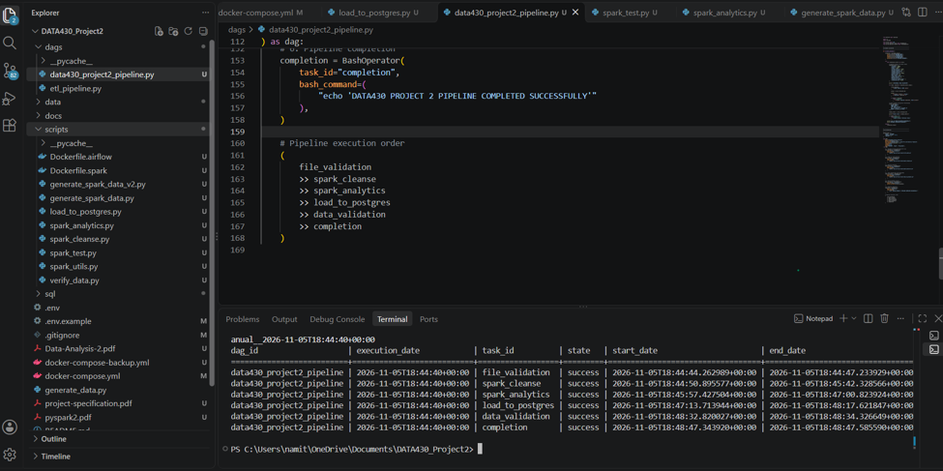
Figure B1. Airflow pipeline execution results showing all six tasks completed successfully on November 5, 2026.
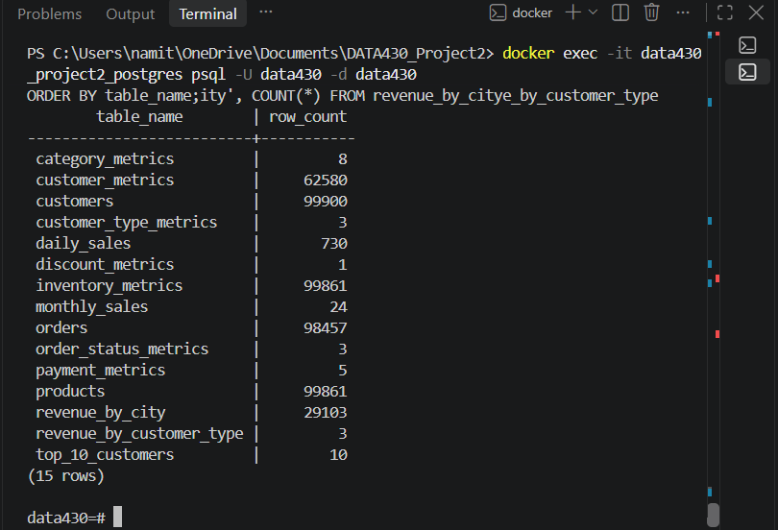
Figure B2. PostgreSQL validation showing 15 database tables and their record counts.
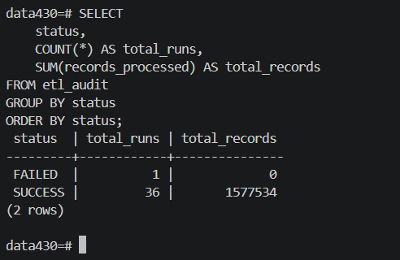
Figure B3. ETL audit summary showing 36 successful runs processing 1,577,534 records and one failed run.

